A Comprehensive Survey of CNN and Transformer-Based Deep Learning Architectures for Brain Tumor MRI Analysis
Para Rajesh¹
¹Research Fellow, Lincoln University College, Malaysia

Abstract
Brain tumor analysis from magnetic resonance imaging (MRI) is an important problem in medical image computing because accurate identification and delineation of tumor tissue support diagnosis, treatment planning, monitoring, and clinical decision-making. Conventional segmentation methods rely on handcrafted intensity, boundary, or region information and are sensitive to noise, intensity inhomogeneity, and anatomical variability [18],[20]. Deep convolutional neural networks (CNNs), particularly Fully Convolutional Networks, U-Net, U-Net++, and nnU-Net, have substantially advanced automated medical image segmentation through hierarchical feature learning and encoder-decoder representations [1]-[3]. However, convolutional operations predominantly model local neighborhoods, which can limit the representation of long-range contextual relationships in heterogeneous tumors [6],[7]. Transformer-based architectures, including Vision Transformer (ViT), Swin Transformer, Swin UNETR, and hybrid models such as CoAtNet, provide attention-based mechanisms for contextual representation learning [4]-[8]. This survey reviews the progression from conventional segmentation to CNN and transformer architectures for brain tumor MRI analysis [1],[2],[6],[7],[20]. It further examines MRI preprocessing, data augmentation, benchmark datasets, evaluation metrics, explainability, robustness, and cross-dataset generalization [12]-[18]. A taxonomy and comparative synthesis are presented to clarify the strengths and limitations of major architectural families. The survey identifies six persistent gaps: preprocessing sensitivity, fragmented multi-task analysis, insufficiently controlled comparisons, limited cross-dataset generalization, inadequate integration of interpretability, and emphasis on benchmark performance over clinical robustness [13]-[16]. Future directions include hybrid CNN-transformer models, self-supervised learning, efficient 3D attention, multimodal fusion, uncertainty-aware prediction, and clinically grounded explainability.
Keywords—Brain tumor MRI, deep learning, CNN, U-Net, nnU-Net, Vision Transformer, Swin Transformer, Swin UNETR, medical image segmentation, explainable AI.

I. INTRODUCTION
Image segmentation partitions an image into meaningful anatomical or pathological regions and is fundamental to quantitative medical image analysis. In brain tumor applications, reliable delineation can support tumor burden assessment, treatment planning, and longitudinal monitoring [18],[20]. Traditional approaches, including thresholding, edge detection, region growing, clustering, and watershed methods, depend strongly on handcrafted criteria and may be affected by noise, intensity non-uniformity, and anatomical variability [18],[20].
MRI is widely used for brain tumor assessment because complementary sequences such as T1, T2, contrast-enhanced T1, and FLAIR provide different anatomical and pathological information [12],[18]. Automated analysis remains challenging because tumors vary in size, shape, location, texture, and internal structure, while acquisition protocols, scanners, patient populations, and annotation availability introduce additional variability [12]-[16].
CNNs established the dominant deep-learning paradigm for medical image analysis. U-Net and its variants became particularly influential because encoder-decoder structures combine semantic representation with spatial reconstruction [1],[3]. More recently, transformer architectures have provided explicit attention-based mechanisms for modeling relationships among distant image regions [4]-[7]. The transition from CNNs to transformers should therefore be interpreted as an evolution of representation learning rather than a simple replacement of one model family by another [5],[6].
The main contributions of this survey are: (1) a unified taxonomy of conventional, CNN-based, and transformer-based approaches; (2) a critical comparison of CNN and transformer representations for brain MRI; (3) a synthesis of preprocessing, datasets, metrics, explainability, and robustness considerations; (4) identification of evidence-based research gaps; and (5) a focused set of future directions for robust and clinically transferable brain tumor AI [13]-[17].

II. SURVEY METHODOLOGY
The survey is organized as a literature-driven synthesis of the material in the source manuscripts. The reviewed scope covers conventional medical image segmentation, CNN-based brain tumor analysis, transformer-based medical image analysis, MRI preprocessing, evaluation, explainability, robustness, and clinical transferability [14]-[20]. The source material specifically emphasizes architectures including U-Net, U-Net++, nnU-Net, ViT, Swin Transformer, Swin UNETR, and CoAtNet [1]-[8].
For a formal IEEE conference submission, the final literature-selection counts should be generated from an actual database search using IEEE Xplore, Scopus, PubMed, ScienceDirect, and SpringerLink. Suggested search terms include “brain tumor MRI,” “brain tumor segmentation,” “CNN,” “U-Net,” “Vision Transformer,” “Swin Transformer,” “Swin UNETR,” and “deep learning MRI.” Duplicate records and studies outside the defined brain-MRI/deep-learning scope should be excluded. Numerical screening counts should not be reported until the search is performed.
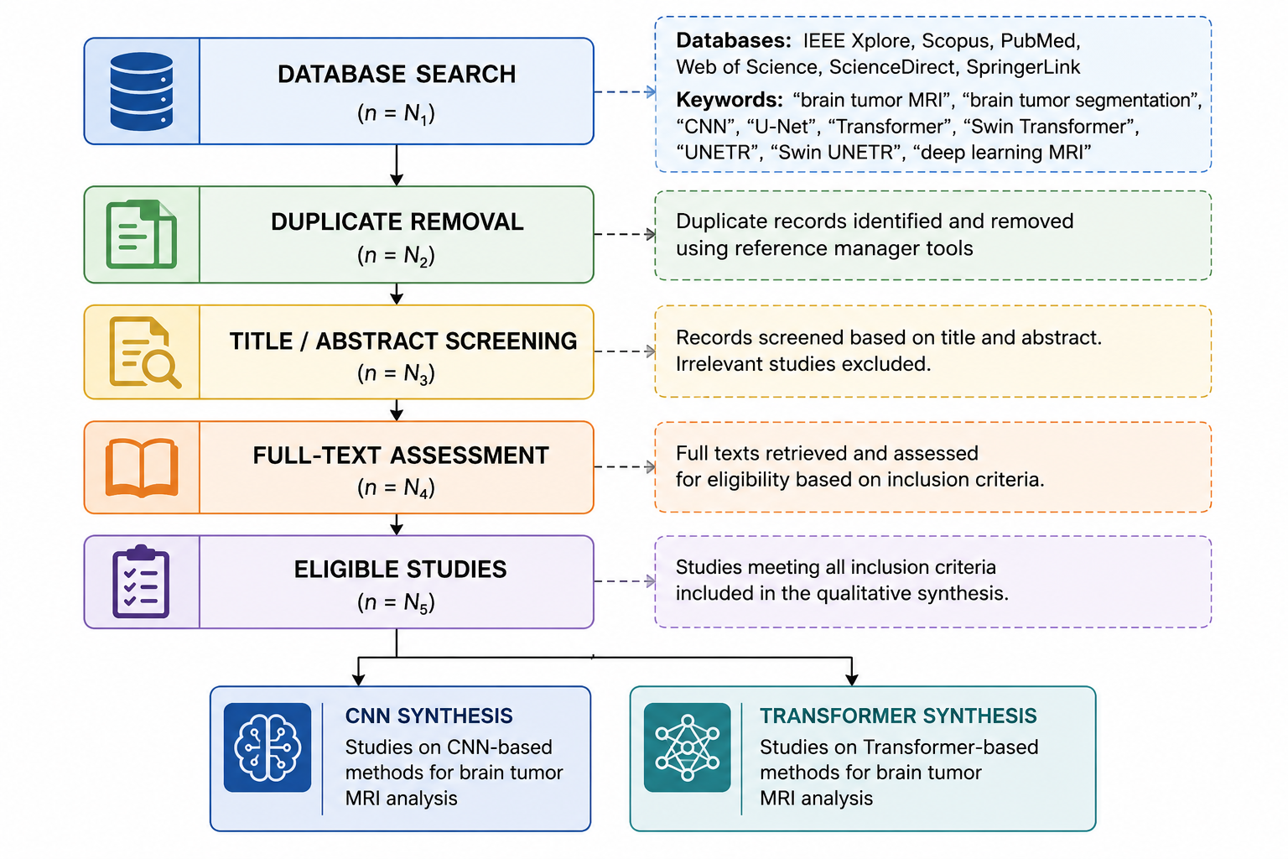
Figure-1 Literature identification and screening workflow

III. FUNDAMENTALS OF BRAIN MRI SEGMENTATION
Medical image segmentation groups pixels or voxels into coherent anatomical or pathological regions. Conventional approaches can be categorized into thresholding, edge-based, region-based, clustering-based, and model-based or probabilistic methods. As displayed in figure-2 These approaches established the conceptual foundation for region extraction but are sensitive to image quality and intensity variability [18],[20].
Core application tasks in brain tumor MRI analysis include:
- Tumor Detection: Identifying the presence of a tumor in MRI scans[14],[15].
- Tumor Localization: Determining the approximate spatial region and boundaries of the tumor [14],[20].
- Tumor Segmentation: Delineating tumor tissue and subregions such as Whole Tumor (WT), Tumor Core (TC), and Enhancing Tumor (ET) [7],[12].
- Tumor Classification: Categorizing tumor types and grades (e.g., Glioma, Meningioma, Pituitary) [15],[20].
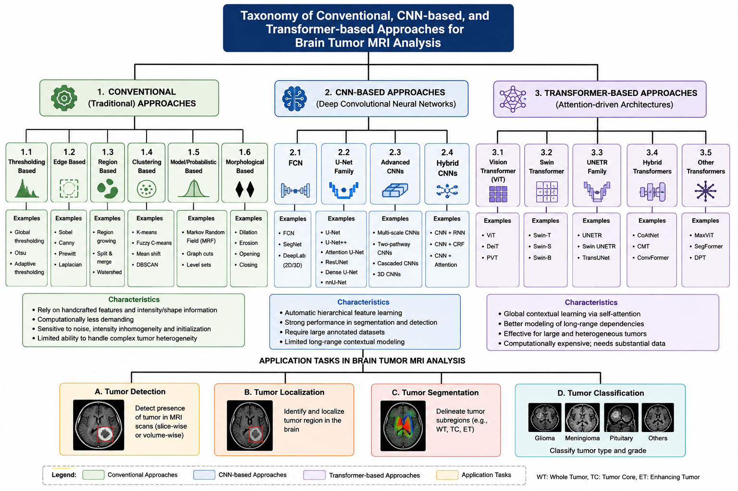
Figure-2: Taxonomy of conventional, CNN-based, and transformer-based approaches for brain tumor MRI analysis

IV. CNN-BASED ARCHITECTURES FOR BRAIN TUMOR MRI ANALYSIS

A. Fully Convolutional Networks
Fully Convolutional Networks replaced fully connected layers with convolutional operations and enabled end-to-end dense pixel-wise prediction. This established an important foundation for semantic segmentation [18,[19]

B. U-Net and Its Variants
U-Net became a highly influential biomedical segmentation architecture through its encoder-decoder design and skip connections [1]. The encoder learns increasingly abstract representations, while skip connections preserve fine-grained spatial information during reconstruction[1]. Variants such as Residual U-Net, Dense U-Net, Attention U-Net, U-Net++, and nnU-Net introduced residual learning, dense feature reuse, attention, nested skip pathways, and self-configuring training strategies [2],[3],[9],[10].

C. CNN-Based Brain Tumor Segmentation
Brain tumors exhibit substantial variation in size, shape, location, texture, and internal structure [12],[14]-[16]. CNN-based methods have therefore explored multi-scale feature learning, two-pathway architectures, and cascaded prediction [16],[20]. Multi-scale CNNs process information at different resolutions, while two-pathway designs combine local and global contextual features. Cascaded networks progressively refine segmentation predictions and can improve boundary delineation [16],[20].

D. Architectural Innovations
Modern CNNs incorporate increased depth, multi-path feature extraction, channel attention, residual and dense connectivity, feature reuse, and attention-based convolutional blocks [9], [10]. These mechanisms increase representation capacity, but the basic convolutional operation remains strongly local, motivating attention-based alternatives [6], [8].
Architecture | Primary task | Key contribution | Strength | Limitation
FCN | Segmentation | Dense prediction | End-to-end learning | Limited contextual range
U-Net | Segmentation | Encoder-decoder + skip connections | Strong localization | Limited global context
U-Net++ | Segmentation | Nested skip pathways | Improved feature fusion | Higher complexity
Attention U-Net | Segmentation | Attention gates | Focuses relevant regions | Additional computation
nnU-Net | Segmentation | Self-configuration | Strong adaptable baseline | Computational cost
Table-1: Representative CNN-based architectures for medical image segmentation.

As per the Figure-3 Evolution of U-Net-based architectures: U-Net → U-Net++ → Attention U-Net → residual/dense variants → nnU-Net.
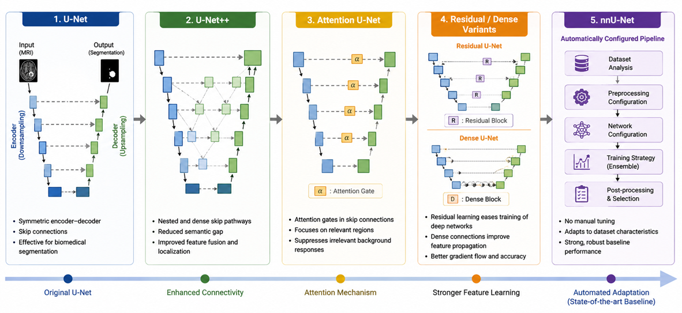
Figure-3: Evolution of U-Net-based architectures

V. TRANSFORMER-BASED ARCHITECTURES FOR BRAIN MRI

A. Vision Transformer
Vision Transformer (ViT) divides an image into patches and represents the resulting patches as token sequences [5]. Self-attention enables interactions among spatially distant tokens and therefore provides a mechanism for contextual representation [4],[5]. However, transformer models can require substantial data or pretraining to learn robust representations [5], [6].

B. Swin Transformer
Swin Transformer introduces hierarchical shifted-window attention. Local attention within windows reduces computational burden, while shifting the windows between stages allows information exchange across neighboring windows. Its hierarchical representation makes the architecture attractive for high-resolution medical images [6],[7].

C. Swin UNETR
Swin UNETR combines a hierarchical Swin Transformer encoder with a U-Net-style decoder for three-dimensional medical image segmentation[7]. The architecture is particularly relevant to volumetric brain MRI because it combines contextual attention with spatial reconstruction. The reviewed manuscript identifies competitive performance on BraTS as evidence of its suitability for brain tumor segmentation [7],[12].

D. CoAtNet
CoAtNet combines convolutional operations with attention-based transformer blocks. This hybrid design seeks to retain the locality advantages of convolution while adding contextual modeling through attention [8].
Figure-4 shown as Conceptual Transformer workflow: MRI → patch embedding → token representation → positional information → multi-head self-attention → contextual feature representation [4]-[7].

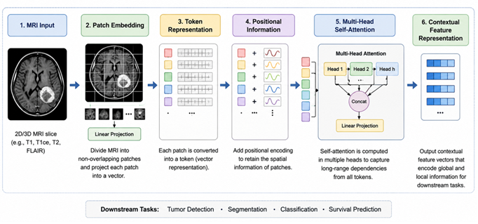
Figure-4: Transformer Based MRI Analysis Pipeline

Figure-5 process as Conceptual Swin UNETR architecture for 3D brain MRI: volumetric input → hierarchical Swin encoder → multi-scale features → U-Net decoder → tumor/subregion segmentation.
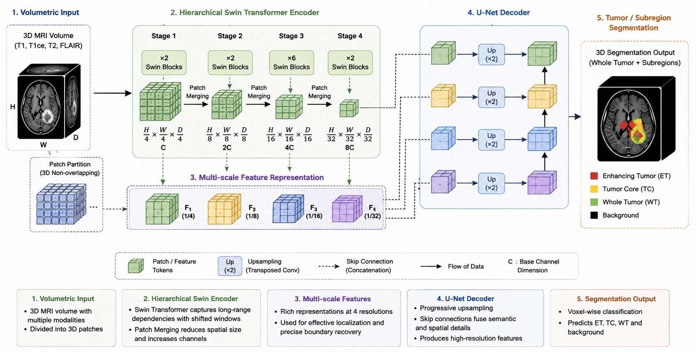
Figure-5: Swin UNETR: Conceptual architecture for 3D brain MRI Segmentation

VI. COMPARATIVE ANALYSIS OF CNN AND TRANSFORMER ARCHITECTURES
- CNNs excel at local feature extraction with strong spatial inductive bias, making them efficient for smaller datasets and local pattern recognition [1], [2], [9], [10].
- Transformers provide global context through self-attention, capturing long-range dependencies effectively for complex, heterogeneous tumors at a higher computational cost ($O\left(N^{2}\right)$ attention scaling) [4]– [7].
- Direct performance comparisons must account for variations in data splits, preprocessing pipelines, baseline configurations, and validation methods [13]– [16].
Criterion | CNN | Transformer
Feature modeling | Local receptive fields | Global/contextual attention
Inductive bias | Strong spatial locality | Weaker inductive bias
Data requirement | Moderate | Often higher
Computational complexity | Generally lower | Generally higher
Long-range dependency | Limited | Strong
3D medical imaging | Mature | Rapidly emerging
Interpretability | Grad-CAM and related methods | Attention visualization plus XAI
Table-2 Comparative characteristics of CNN and transformer architectures for brain MRI analysis.
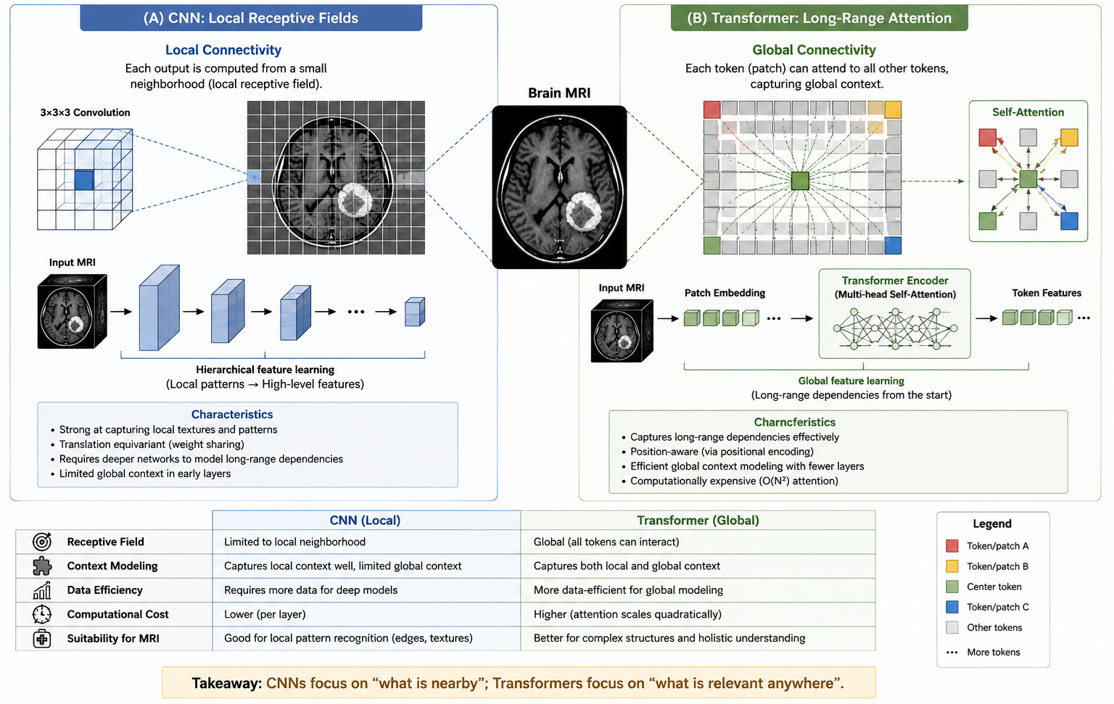
Figure-6: Conceptual comparison of CNN local receptive fields and Transformer long-range attention.

VII. MRI PREPROCESSING AND DATA AUGMENTATION
Preprocessing can substantially influence deep-learning performance[14]–[16]. The reviewed material identifies denoising, contrast enhancement, bias-field correction, and intensity normalization as important operations [18]. Non-Local Means can reduce noise while preserving anatomical structures; CLAHE can enhance local contrast; N4 bias-field correction addresses intensity inhomogeneity; and normalization reduces variation across scanners and acquisition protocols. The literature also indicates that preprocessing sensitivity is insufficiently evaluated in many studies.
For augmentation, anatomically plausible transformations should be selected according to the imaging task. Candidate operations include rotation, translation, scaling, elastic deformation, random cropping, and controlled intensity perturbation. Augmentation should be evaluated rather than assumed to improve performance because its effect may depend on dataset characteristics [18],[19].
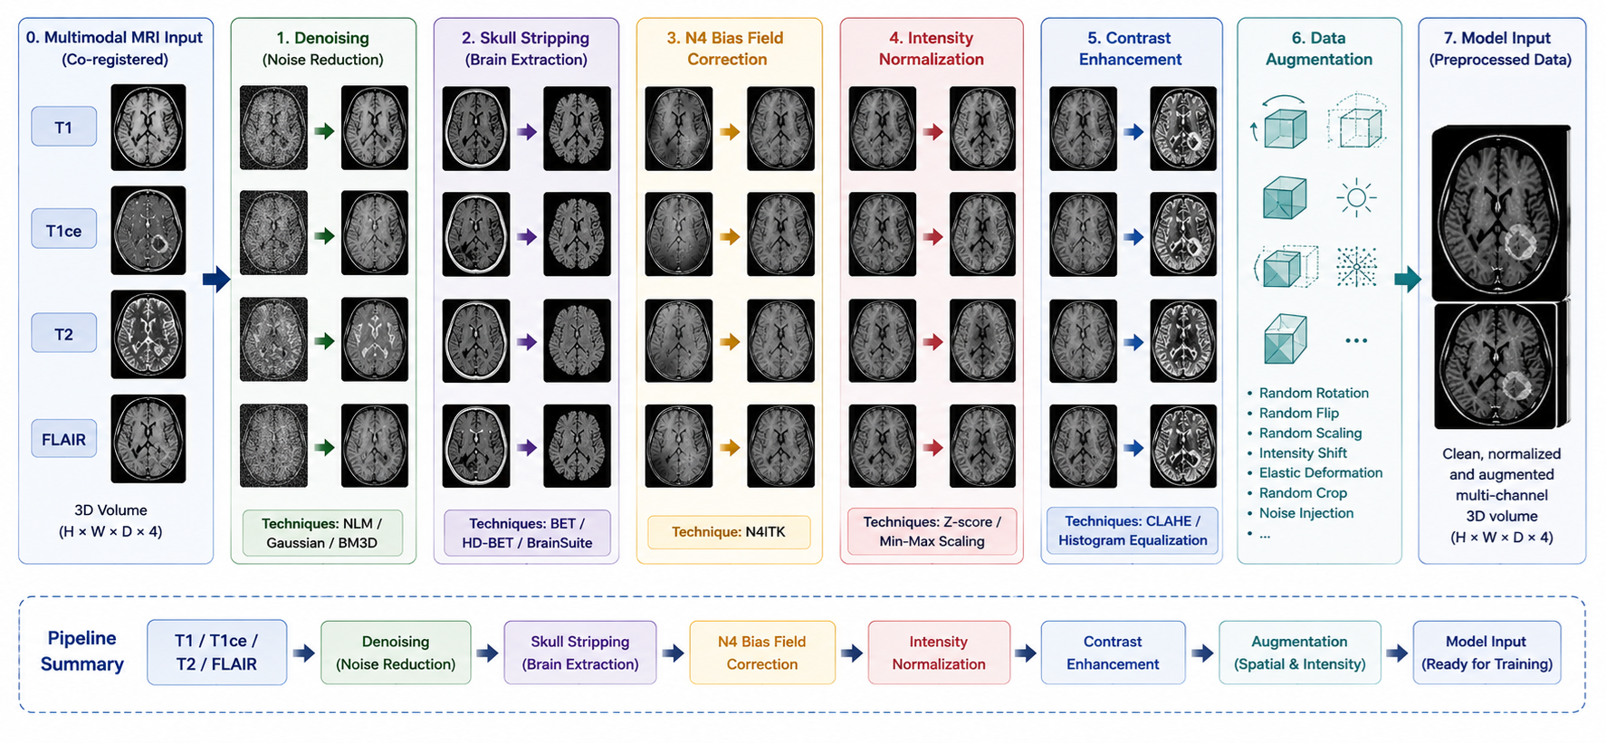
Figure-7: Multimodal MRI preprocessing pipeline

VIII. DATASETS AND EVALUATION METRICS
The BraTS benchmark is a central reference point in the reviewed literature for brain tumor segmentation and radiogenomic classification [12]. The source manuscript also emphasizes that dataset composition, class balance, preprocessing, patient-level splitting, and validation methodology can strongly influence classification and segmentation results [13]-[16].
Dataset | Modalities | Primary task | Annotation
BraTS | T1, T1ce, T2, FLAIR | Brain tumor segmentation | Tumor regions/subregions
Table-3: Representative benchmark dataset identified in the reviewed literature. Additional datasets should be added only after verification from the final literature search.

Evaluation Metrics:
- Detection and classification metrics include Accuracy, Precision, Recall/Sensitivity, Specificity, F1-score, MCC, and AUC-ROC [14],[15].
- Segmentation metrics encompass the Dice similarity coefficient, Intersection over Union (IoU), Sensitivity, Specificity, and boundary distance measures like Hausdorff Distance [12],[16].
Dice = 2|P ∩ G| / (|P| + |G|)
IoU = |P ∩ G| / |P ∪ G|
Using multiple metrics is important because overlap measures alone do not fully characterize boundary errors or failure cases [12], [14], [16].

IX. INTEGRATED BRAIN TUMOR MRI ANALYSIS PIPELINE
The reviewed literature supports an integrated view in which MRI acquisition, preprocessing, detection, localization, segmentation, classification, robustness evaluation, and explainability are interconnected stages [14]– [18]. Existing studies often treat these tasks independently, which motivates a unified analytical framework [14]– [16].
Task | Representative architecture
Tumor detection | Swin Transformer
Tumor segmentation | Swin UNETR
Tumor classification | CoAtNet
CNN detection/classification baselines | ResNet, DenseNet, EfficientNet
CNN segmentation baselines | U-Net, U-Net++, nnU-Net
Table-4: Representative architecture mapping based on the reviewed literature; the mapping is not presented as an experimentally validated result.
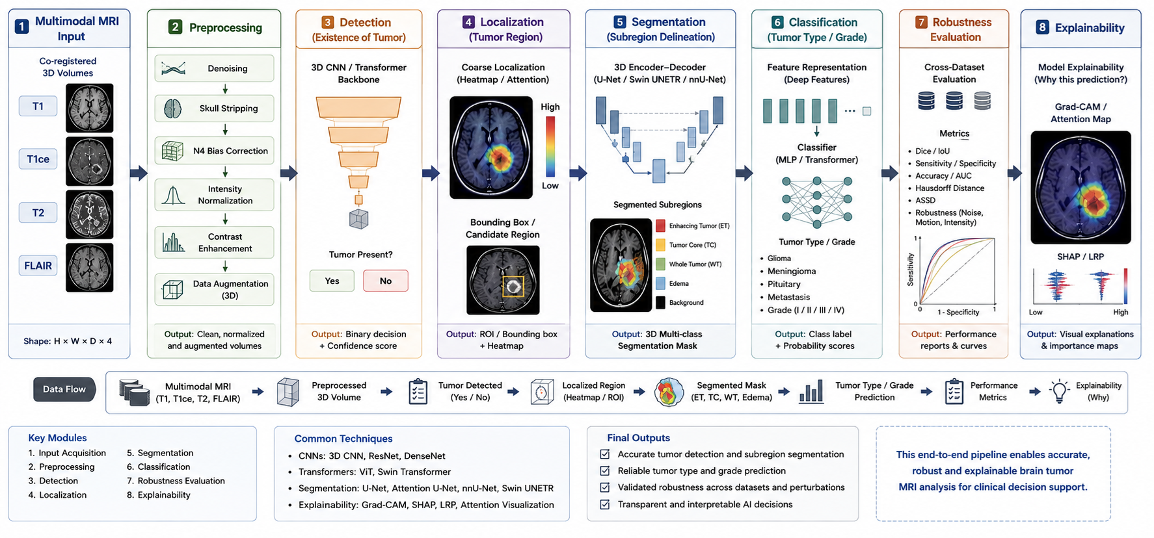
Figure-8: Integrated brain tumor MRI analysis pipeline

X. EXPLAINABLE AI AND ROBUSTNESS
Clinical adoption requires evidence that models focus on clinically meaningful regions. Candidate explainability approaches include Grad-CAM, Grad-CAM++, attention-map visualization, occlusion sensitivity analysis, and feature attribution[17], [18]. These methods provide complementary evidence about model behavior but should not be interpreted as definitive proof of clinical reasoning[17].
Method | Typical model | Output | Limitation
Grad-CAM | CNN | Activation heatmap | Primarily class-discriminative
Grad-CAM++ | CNN | Refined heatmap | Additional computation
Attention visualization | Transformer | Attention regions | Attention is not necessarily causal
Occlusion analysis | CNN/Transformer | Importance map | Computationally expensive
Table-5: Representative explainability approaches for brain tumor AI.
Robustness should distinguish internal validation from generalization. Patient-level splitting, cross-validation, independent testing, cross-dataset evaluation, preprocessing sensitivity analysis, and class-wise performance are preferable to relying only on repeated random splits from one dataset [13]– [16].

XI. RESEARCH GAPS, CHALLENGES, AND SOLUTIONS
The combined literature identifies six major gaps: preprocessing sensitivity, fragmented multi-task analysis, insufficiently controlled comparative evaluation, limited cross-dataset generalization, inadequate integration of interpretability, and emphasis on benchmark performance rather than broader clinical robustness [13]– [16].
Research gap | Observed problem | Consequence | Recommended solution
Preprocessing sensitivity | Individual operations are often assumed | Contribution of preprocessing is unclear | Systematic preprocessing ablation
Fragmented multi-task analysis | Detection, segmentation and classification evaluated separately | Limited end-to-end clinical representation | Unified multi-task evaluation
Controlled comparison | CNN baselines may be inconsistently configured | Unreliable improvement claims | Equivalent splits, training and metrics
Cross-dataset generalization | High performance on one benchmark | Dataset/acquisition bias | External and cross-dataset validation
Interpretability integration | XAI often post-hoc | Limited confidence in model behavior | Quantitative and clinically grounded XAI
Clinical transferability | Benchmark metrics dominate | Limited deployment evidence | Robustness, uncertainty and workflow validation
Table-6: Major research gaps and recommended methodological solutions.
CNN challenges include limited global context, sensitivity to perturbations, hyperparameter dependence, limited interpretability, and difficulty representing spatial relationships [6], [8], [14]– [16]. Transformer challenges include high computational and memory requirements, dependence on substantial training data or pretraining, instability on small datasets, and high inference cost for 3D volumes [5]– [7], [14]– [16]. The reviewed literature suggests optimization, augmentation, transfer learning, self-supervised learning, and hybrid CNN-transformer architectures as potential responses [5]– [8], [13]– [16].

XII. FUTURE RESEARCH DIRECTIONS

A. Hybrid CNN-Transformer Architectures
Combining convolutional inductive biases with transformer attention may improve the balance between local detail, contextual representation, and computational efficiency [8],[13].

B. Self-Supervised and Foundation Models
Pretraining on large collections of unlabeled medical images may reduce dependence on expert annotations [14]-[16].

C. Cross-Dataset Generalization
External validation across institutions, scanners, and patient populations should become a routine component of evaluation [13]-[16].

D. Uncertainty-Aware Segmentation
Uncertainty estimation can provide risk-aware predictions and improve clinical trustworthiness[14]-[16].

E. Multimodal MRI Fusion
Integration of T1, T2, FLAIR, diffusion, perfusion, and radiomic information may better represent tumor heterogeneity[12]-[16].

F. Clinically Grounded Explainability
Radiologist validation and quantitative comparison between explanations and tumor annotations can strengthen the clinical relevance of XAI [17]-[18].
These directions are consistent with the reviewed manuscript, which identifies hybrid architectures, self-supervised learning, cross-dataset validation, uncertainty-aware modeling, multimodal fusion, and clinically grounded explainability as promising areas [13],[16].

XIII. CONCLUSION
This survey reviewed the evolution from conventional segmentation to CNN-based and transformer-based architectures for brain tumor MRI analysis [1]– [8], [14]– [20]. CNNs, including FCN, U-Net, U-Net++, and nnU-Net, established strong foundations for automated segmentation through hierarchical feature learning and spatial reconstruction [1]– [3]. Transformer architectures, including ViT, Swin Transformer, Swin UNETR, and CoAtNet, provide alternative mechanisms for contextual representation and are particularly relevant to heterogeneous and volumetric tumor structures [5]– [8].
The synthesis indicates that transformers should not be regarded simply as replacements for CNNs. Meaningful comparison requires controlled data splits, strong baselines, multiple metrics, ablation studies, robustness testing, and failure-case analysis [13]– [16]. The major unresolved issues concern preprocessing sensitivity, multi-task integration, controlled comparison, cross-dataset generalization, interpretability, and clinical transferability [13]-[17]. Future progress is therefore likely to depend on hybrid representations, self-supervised learning, efficient 3D attention, multimodal fusion, uncertainty estimation, and clinically validated explainability [7], [8], [13]– [17].
Summarizes the evolution from conventional techniques to advanced CNNs and transformer frameworks (such as Swin UNETR and CoAtNet) for brain tumor MRI analysis, reinforcing that future progress relies on hybrid representations, robustness, and clinical transferability.

REFERENCES
[1] O. Ronneberger, P. Fischer, and T. Brox, “U-Net: Convolutional Networks for Biomedical Image Segmentation,” MICCAI, 2015. (Represents foundational biomedical CNN segmentation)
[2] F. Isensee et al., “nnU-Net: A Self-Configuring Method for Deep Learning-Based Biomedical Image Segmentation,” Nature Methods, vol. 18, pp. 203–211, 2021. (Represents automated, self-configuring CNN pipelines)
[3] J. Zhou et al., “UNet++: A Nested U-Net Architecture for Medical Image Segmentation,” DLMIA, 2018. (Represents nested skip pathways for medical image segmentation)
[4] A. Vaswani et al., “Attention Is All You Need,” NeurIPS, vol. 30, 2017. (Represents the fundamental Transformer architecture utilized for attention mechanisms)
[5] A. Dosovitskiy et al., “An Image Is Worth 16×16 Words: Transformers for Image Recognition at Scale,” ICLR, 2021. (Represents Vision Transformers / ViT adaptation for images)
[6] Z. Liu et al., “Swin Transformer: Hierarchical Vision Transformer Using Shifted Windows,” Proc. IEEE/CVF ICCV, pp. 10012–10022, 2021. (Represents Swin Transformer and hierarchical attention)
[7] A. Hatamizadeh et al., “Swin UNETR: Swin Transformers for Semantic Segmentation of Brain Tumors in MRI Images,” 2022. (Represents Swin UNETR tailored directly for 3D brain tumor MRI segmentation)
[8] Z. Dai et al., “CoAtNet: Marrying Convolution and Attention for All Data Sizes,” Advances in Neural Information Processing Systems, vol. 34, 2021. (Represents hybrid CNN-transformer classification architectures)
[9] K. He et al., “Deep Residual Learning for Image Recognition,” Proc. IEEE/CVF CVPR, pp. 770–778, 2016. (Represents residual learning networks for deep feature extraction)
[10] G. Huang et al., “Densely Connected Convolutional Networks,” Proc. IEEE/CVF CVPR, pp. 4700–4708, 2017. (Represents dense connections improving feature propagation)
[11] M. Tan and Q. V. Le, “EfficientNet: Rethinking Model Scaling for Convolutional Neural Networks,” ICML, pp. 6105–6114, 2019. (Represents efficient convolutional baselines for image tasks)
[12] U. Baid et al., “The RSNA-ASNR-MICCAI BraTS 2021 Benchmark on Brain Tumor Segmentation and Radiogenomic Classification,” 2021. (Represents the standard BraTS benchmarking reference)
[13] D. Zhang et al., “Scalable Swin Transformer Network for Brain Tumor Segmentation from Incomplete MRI Modalities,” Artificial Intelligence in Medicine, vol. 149, 102788, 2024. (Represents advanced Swin Transformer applications for incomplete MRI modalities)
[14] T.-W. Wang et al., “Artificial Intelligence Detection and Segmentation Models: A Systematic Review and Meta-Analysis of Brain Tumors in Magnetic Resonance Imaging,” 2024. (Represents systematic reviews and meta-analysis of brain tumor AI)
[15] S. Bouhafra and H. El Bahi, “Deep Learning Approaches for Brain Tumor Detection and Classification Using MRI Images (2020–2024): A Systematic Review,” Journal of Imaging Informatics in Medicine, 2025. (Represents recent systematic reviews on brain tumor detection and classification)
[16] A. Yadav et al., “Brain Tumor Segmentation with Deep Learning: Current Approaches and Future Perspectives,” Journal of Neuroscience Methods, 2025. (Represents current approaches and future perspectives in deep learning tumor segmentation)
[17] R. R. Selvaraju et al., “Grad-CAM: Visual Explanations from Deep Networks via Gradient-Based Localization,” Proc. IEEE/CVF ICCV, pp. 618–626, 2017. (Represents gradient-based localization for deep model interpretability)
[18] S. K. Zhou, H. Greenspan, and D. Shen, Eds., Deep Learning for Medical Image Analysis, 2nd ed. Elsevier, 2023. (Represents comprehensive literature on deep learning in medical imaging)
[19] I. Goodfellow, Y. Bengio, and A. Courville, Deep Learning. MIT Press, 2016. (Represents foundational deep learning theory and methodology)
[20] E. S. Biratu et al., “A survey of brain tumor segmentation and classification algorithms,” Journal of Imaging, vol. 7, no. 9, p. 179, 2021. (Represents surveys on brain tumor segmentation and classification algorithms)

