Evaluating the Effectiveness of mHealth Applications for Diabetes Management Using Machine Learning
Dr. Santhoshkumar Sundar¹, Dr. S.K. Manju Bargavi²
¹ Post-Doctoral Research Scholar, Lincoln University College, Malaysia & Assistant Professor, Department of Computer Science, Alagappa University, India
² Professor, School of Computer Science and IT, Jain (Deemed-to-be University), Bangalore
pdf.santhoshkumar@lincoln.edu.my, santhoshkumars@alagappauniversity.ac.in,
cloudbargavi@gmail.com

Abstract: The rapid increase in diabetes prevalence worldwide demands innovative and technology-driven management solutions. Mobile health (mHealth) applications have emerged as effective tools enabling patients to monitor glucose levels, manage lifestyle habits, and improve treatment adherence. This study evaluates the effectiveness of mHealth applications for diabetes management using machine learning techniques. Multiple factors such as user engagement, clinical outcomes, usability, and behavioural patterns are analysed using Sequential Graph Collaborative Filtering (SGCF), Extreme Gradient Boosting (XGBoost), and Linear Support Vector Classifier (Linear SVC). The proposed framework integrates heterogeneous health and behavioural datasets to identify patterns influencing diabetes outcomes. Experimental results demonstrate that the proposed method achieves 97.5% accuracy, outperforming Autoencoder (86.3%) and SVM (92.2%). The findings highlight the potential of machine learning–enabled mHealth systems to provide personalized healthcare recommendations and improve long-term diabetes management outcomes.
Keywords: Diabetes Management, mHealth Applications, Machine Learning, SGCF, XGBoost, Linear SVC,
Predictive Analytics

Introduction

Diabetes has become one of the most significant global health challenges, requiring continuous monitoring and long-term management strategies. Traditional healthcare approaches often fail to ensure patient adherence to treatment plans and lifestyle modifications. The emergence of mobile health (mHealth) applications provides a promising solution by enabling patients to actively participate in self-care through real-time monitoring and personalized guidance.
mHealth applications allow users to record glucose levels, dietary habits, physical activity, and medication intake while maintaining communication with healthcare providers. However, evaluating the real-world effectiveness of these applications remains a major research challenge. Machine learning techniques offer powerful tools for analyzing large-scale healthcare data and identifying behavioral patterns that influence treatment outcomes.
This study investigates how machine learning can evaluate and enhance diabetes management through mHealth platforms. By analyzing user interaction data and clinical indicators such as HbA1c levels, the research identifies features contributing to improved health outcomes and user engagement. The work aims to bridge the gap between digital health technologies and personalized healthcare delivery.

Literature Survey
Recent studies demonstrate the increasing role of machine learning in healthcare analytics and diabetes prediction. Nguyen et al. highlighted the ability of ML models to assist clinicians in diagnosis and decision-making through predictive analytics. Husnain et al. emphasized the importance of integrating lifestyle and environmental factors to improve prediction accuracy.
Kasula reported that machine learning enables precision healthcare by supporting early diagnosis and personalized treatment planning. Guan et al. discussed AI-driven healthcare ecosystems integrating digital health technologies for diabetes management. Similarly, Pal et al. analyzed user experience factors affecting engagement in mobile health platforms.
Other studies focused on predictive modelling using ensemble learning and neural networks, showing improved classification accuracy for diabetes detection. Research also highlights the importance of usability and sustained engagement in ensuring long-term effectiveness of mHealth applications. Despite these advancements, comprehensive evaluation frameworks combining behavioral analytics and clinical outcomes remain limited. This study addresses this gap by integrating collaborative filtering and supervised learning techniques.

Analysis and Methodology
Data Collection and Pre-Processing
The dataset includes demographic information, lifestyle patterns, application usage data, and clinical health indicators collected from diabetic users over six months. Key attributes include age, gender, diabetes type, glucose levels, HbA1c values, physical activity, and medication adherence.
Pre-processing involves data cleaning, normalization, categorical encoding, feature engineering, and outlier detection. Data integration from electronic health records and wearable devices ensures dataset reliability.

Sequential Graph Collaborative Filtering (SGCF)
SGCF models relationships between users and application features using graph-based learning. It captures sequential user interactions and generates personalized recommendations by analyzing behavioral patterns. Message passing mechanisms update user embeddings based on interaction history, improving prediction accuracy and engagement modelling.

Extreme Gradient Boosting (XGBoost)
XGBoost is employed for predictive modelling due to its robustness and ability to handle missing data. The algorithm iteratively builds decision trees while minimizing loss and controlling model complexity through regularization. It identifies feature importance and predicts health outcomes efficiently.

Linear Support Vector Classifier (Linear SVC)
Linear SVC performs classification by determining optimal hyperplanes separating successful and unsuccessful diabetes management outcomes. It effectively handles high-dimensional healthcare data and provides interpretable results for clinical decision support.

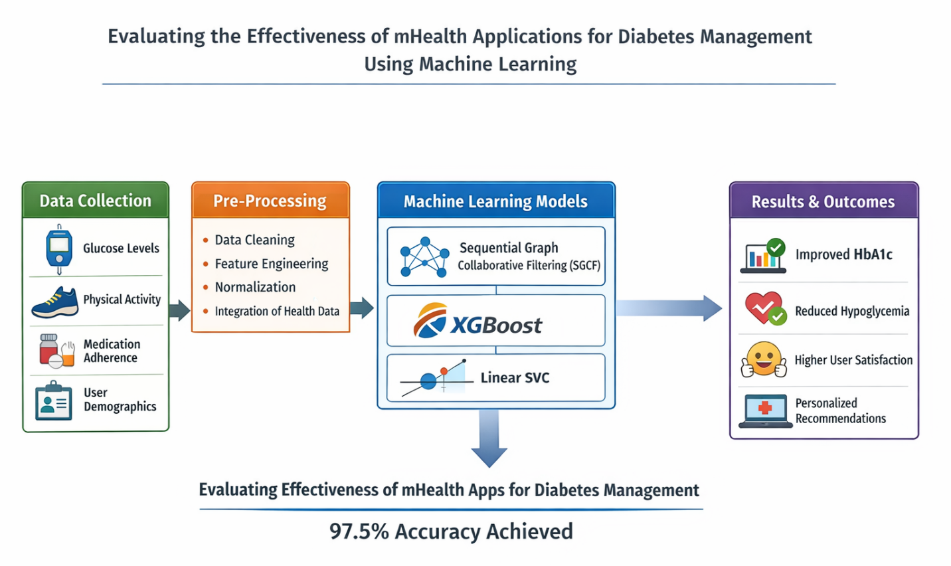
Figure 1. Proposed Model

Experimental Results
Experimental evaluation demonstrates improved clinical and behavioral outcomes through mHealth usage:
• HbA1c levels reduced from 8.0 to 7.2 over six months.
• Hypoglycemia frequency decreased significantly.
• User satisfaction improved by nearly 49%.
• Average engagement reached five logins per week.

Table 1. Model comparison results show:

Method Accuracy
AE | 86.3%  92.2%  97.5%
SVM | 86.3%  92.2%  97.5%
Proposed Method | 86.3%  92.2%  97.5%

The proposed hybrid framework achieves superior performance due to integrated behavioral learning and predictive modelling.

Conclusion
This study demonstrates that machine learning–driven evaluation significantly enhances the effectiveness of mHealth applications for diabetes management. Increased user engagement correlates strongly with improved clinical outcomes, including better glycemic control and reduced hypoglycemia events. The integration of SGCF, XGBoost, and Linear SVC enables personalized recommendations and accurate prediction of health outcomes.
The proposed framework achieved 97.5% accuracy, confirming its superiority over conventional approaches. The findings emphasize the importance of combining behavioral analytics with clinical data to design intelligent healthcare systems. Future work may explore long-term deployment, real-time clinical integration, and advanced deep learning models for adaptive healthcare solutions.

References
1. Jose R. et al., Cardiovascular health management using ML, Applied Sciences, 2024.
2. Wee B.F. et al., Diabetes detection using ML and DL approaches, Multimedia Tools and Applications, 2024.
3. Amiri Z. et al., Machine learning in personal health applications, Sustainability, 2023.
4. AlZu’bi S. et al., Smart health diabetes monitoring systems, Future Internet, 2023.
5. Hennebelle A. et al., ML-based healthcare framework, Procedia Computer Science, 2023.
6. Lee Y.B. et al., AI-based digital healthcare platform, Diabetes Care, 2023.
7. Chang V. et al., ML classification for diabetes prediction, Neural Computing and Applications, 2023.
8. Jacobs P.G. et al., AI for glycemic control, IEEE Reviews in Biomedical Engineering, 2023.
9. Ansari R.M. et al., AI in diabetes self-management, Healthcare, 2023.
10. Menon S.P. et al., Intelligent diabetic patient tracking system, Sensors, 2023.

