A Mathematical Model of Nano-Based Drug Delivery to study the Effect of anti-CD147 drug on Tumor Angiogenesis
Dr Bhooma S¹, Dr Rajendra Kumar Tripathi²
¹Postdoctoral Fellow, LGPR, Lincoln University College, Malaysia; ²Khwaja Moinuddin Chishti Language University, Lucknow
Email ID pdf.bhooma@lincoln.edu.my; drrktripathi_fgiet@rediffmail.com

Abstract: The growth of new vasculature from existing vasculature is termed as Tumor angiogenesis. Tumor Angiogenesis Factors (TAFs), Matrix Metallo Proteinases (MMPs), fibronectin etc. assist in the process of tumor angiogenesis. These factors enable the Endothelial Cells (ECs) to migrate from the parent blood vessel to the tumor. A transmembrane glycoprotein called Extracellular Matrix Metallo Proteinases Inducer / Cluster of Differentiation 147 (EMMPRIN / CD147), aids in tumor angiogenesis by increasing the TAF and MMP concentrations. To prevent or delay the completion of angiogenesis, an anti-CD147 drug which is encapsulated in a nanoparticle is applied. The mathematical formulation consists of partial differential equations (PDEs) and the encapsulation of the drug in the nanoparticle ensures that the drug is delivered to the site of interest. Further, release of the drug from the nanoparticle and its impact are modeled. The simulations are performed in COMSOL Multiphysics 5.4 software. The results show that having a high concentration of the drug in the delivery site, through a controlled release, is more effective than single administration of the drug.

Keywords: tumor angiogenesis; mathematical model; CD147; anti-CD147 drug; nanoparticle drug delivery.

Introduction

Tumor angiogenesis is a crucial process for tumor growth. The tumor ensures that it has sufficient nutrients and oxygen for its growth and hence, it secretes Tumor Angiogenesis Factors (TAFs) and Matrix Metallo Proteinases (MMPs) in the neighborhood. This results in the Endothelial Cells (ECs) to migrate towards the source of TAFs. This leads to the formation of new blood vessels [1]. During this process, there has to be space for the new blood vessels to grow and the MMPs degrade the Extra Cellular Matrix (ECM) thereby creating a space for the new blood vessels [2, 3]. A transmembrane glycoprotein called Cluster of Differentiation 147 (CD147) increases the TAFs and MMPs, thus, contributing to tumor angiogenesis. Hence, to slow down tumor angiogenesis, targeting CD147 molecule becomes essential [4, 5]. For this purpose, a suitable anti-CD147 drug encapsulated in a nanoparticle is used. The drug encapsulation in a nanoparticle ensures that the drug is delivered to the desired site.

Related work
In 2025, Tsiros et al. [6], have created a compartmental model to evaluate medication delivery by nanoparticle. Also, they have researched the physicochemical features and their impact on the nanoparticle accumulation, localization and disposition. They came to the conclusion that better drug delivery to the target site results from the optimization of nanoparticle characteristics. In 2025, Koutsi et al. [7], have researched mechanotherapeutics and sonopermeation with the use of a mechanistic model. They have thought about using nano-immunotherapy to treat cancer. They came to the conclusion that the model does a good job of explaining how different molecules interact with therapy methods. The mobility of nanoparticles around a tumor has been investigated by Shabbir et al. [8]. They came to the conclusion that the increased vessel diameter improved the nanoparticle flow.

Key Contribution
The present study deals with the delivery of drug encapsulated in nanoparticles. An anti-CD147 drug is encapsulated in a nanoparticle is studied. Further, the effect of the drug on tumor angiogenesis is explored.

Methods, Results and Discussion
To analyze the effects of anti-CD147 drug encapsulated in a nanoparticle on tumor angiogenesis, a mathematical model is developed. The concentration of TAFs, MMPs, CD147, anti-CD147 drug, tumor cells and nanoparticles are modeled as partial differential equations (PDEs). The tumor secretes TAFs and MMPs which lead to the ECs to move toward the tumor. This leads to the formation of tumor angiogenesis. This process is aided by CD147 and to counter its effects, a drug that specifically targets CD147 molecule is considered. Further, this drug is encapsulated in a nanoparticle (NP) to ensure the drug is delivered to the exact tumor site. The equation for free drug (the drug that is not encapsulated in the NP) and the equation for the NP-drug (the drug that is encapsulated in the NP) are considered. Reaction-diffusion equations are used to model them. The values of the parameters are taken from existing literature. Sensitivity analysis is carried out for certain parameters that are not found in the literature. The simulations are done in COMSOL Multiphysics software. The findings indicate that the drug's action has reduced the incidence of angiogenesis. The concentration of CD147 is decreased by the medication contained in the NP. This leads to a decrease in TAFs and MMPs. As a result, angiogenesis progresses more slowly.
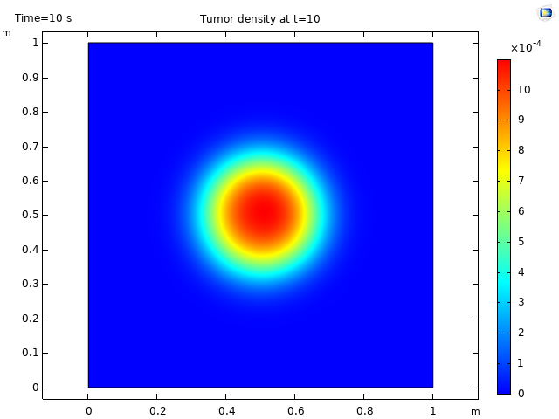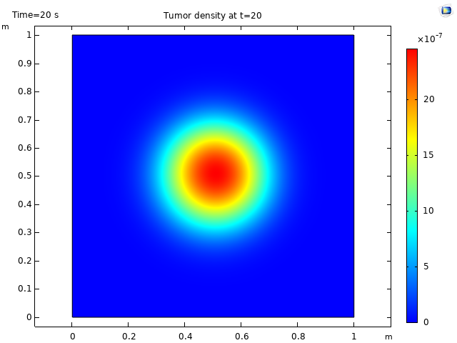

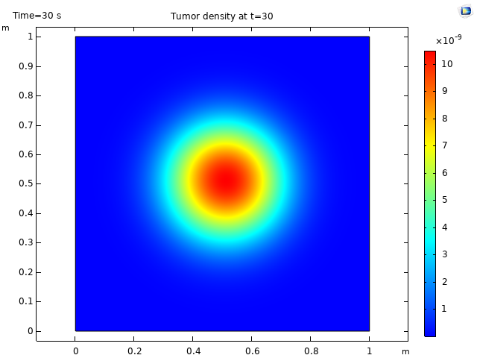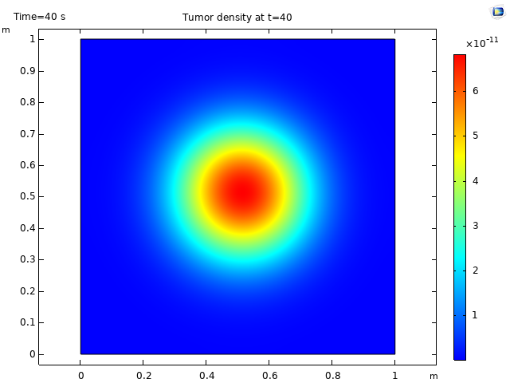
Fig.1: Tumor cell density for different times.

In Figure 1, the tumor cell density for various times is plotted. As time progresses, there is a reduction in the tumor cell density. The effect of anti-CD147 drug, which is encapsulated in a Nano Particle, has a significant effect on tumor growth. This reduction in the tumor is due to the controlled release of the drug via the nanoparticle.

Conclusions
- Tumor angiogenesis is successfully targeted. The CD147 molecule was the main focus, and strategies for reducing its effects were investigated.
- To curb the influence of CD147 on tumor angiogenesis, the anti-CD147 drug was encapsulated in a NP and was observed to be effective.
- The limitations of the present work include - the study does not examine combinatorial therapy. Additionally, the angiogenesis process involves a number of other pathways. Tumor angiogenesis may be more effectively treated by focusing on these pathways in addition to CD147.

References
- N. Paweletz and M. Knierim, ‘‘Tumor-Related Angiogenesis’’, Critical Reviews in Oncology/Hematology, vol. 9, no. 3, pp. 197–242, 1989.
https://pubmed.ncbi.nlm.nih.gov/2480145/
- J.E. Rundhaug, ‘‘Matrix metalloproteinases and angiogenesis’’, Journal of Cellular and Molecular Medicine, vol. 9, no. 2, pp. 267–285, 2005.
https://pubmed.ncbi.nlm.nih.gov/15963249/
- C. Gialeli, A.D. Theocharis and N.K. Karamanos, ‘‘Roles of matrix metalloproteinases in cancer progression and their pharmacological targeting’’, FEBS Journal, vol. 278, no. 1, pp. 16–27, 2011.
https://pubmed.ncbi.nlm.nih.gov/21087457/
- L. Xiong, C.K. Edwards III and L. Zhou, “The Biological Function and Clinical Utilization of CD147 in Human Diseases: A Review of the Current Scientific Literature”, International Journal of Molecular Sciences, vol. 15, no. 10, pp. 17411–17441, 2014.
https://www.mdpi.com/1422-0067/15/10/17411
- Z. Wang, Z. Zhao, T. Jiang, Y. Chen and C. Huang, “The multistep functions of EMMPRIN/CD147 in the tumor angiogenesis”, Cellular and Molecular Medicine, vol. 2, no. 12, pp. 1–5, 2016.
https://cellular-molecular-medicine.imedpub.com/articles/the-multistep-functions-of-emmprin-cd147-in-the-tumor-angiogenesis.php?aid=9257
- P. Tsiros, N. Chimarios, D. Zouraris, A. Tsoumanis, H. Sarimveis, G. Melagraki, I. Lynch and A. Afantitis, “Optimizing nanoparticle-mediated drug delivery: insights from compartmental modeling via the CompSafeNano cloud platform”, RSC Sustainability, vol. 3, pp. 1494 – 1506, 2025.
https://www.sciencedirect.com/org/science/article/pii/S2753812525000229
- M. Koutsi, T. Stylianopoulos and F. Mpekris, “Synergistic mechanotherapy and sonopermeation guided by mathematical modeling for solid tumor treatment”, Frontiers in Drug Delivery, vol. 5, pp. 1549098: 1 – 17, 2025.
https://www.frontiersin.org/journals/drug-delivery/articles/10.3389/fddev.2025.1549098/full
- F. Shabbir, A. A. Mujeeb, S.F. Jawed, A. H. Khan and C. S. Shakeel, “Simulation of transvascular transport of nanoparticles in tumor microenvironments for drug delivery applications”, Scientific Reports, vol. 14, pp. 1764:1 – 15, 2024.
https://pubmed.ncbi.nlm.nih.gov/38242952/

