A Secure and Explainable Cyber Threat Intelligence Framework for Distributed Digital Infrastructures
Vinayak Musale¹, Basant Kumar²
¹ Lincoln University College, Malaysia; ² Modern College of Business and Science, Oman
pdf.vinayak@lincoln.edu.my¹; basant@mcbs.edu.om²

Abstract: The rapid adoption of IoT, edge computing and cloud platforms has introduced extensive cybersecurity challenges associated with data privacy, trust management and secure exchange of threat intelligence. The traditional security approaches typically depend on centralized processing, where large volumes of sensitive information are transferred and stored. This results into increase in the risk of privacy breaches. This paper presents the implementation of a privacy preserving cybersecurity framework that combines federated learning, differential privacy, blockchain technology and explainable artificial intelligence within a unified architecture. The proposed framework supports collaborative intrusion detection by allowing participating entities to train shared models locally without exposing raw data. It ensures transparency and trust throughout the learning process. A prototype was implemented using distributed learning nodes, a permissioned blockchain network and explainable analytics modules. The implementation integrates decentralized model training, privacy aware parameter sharing, blockchain based verification and interpretable threat classification to enable secure cybersecurity operations across heterogeneous computing environments. In turn, the methodology determines that these complementary technologies can be effectively integrated to deliver scalable, transparent and trustworthy cyber defense for next generation digital ecosystems.
Keywords: Blockchain; Cybersecurity; Explainable AI; Federated Learning; IoT; Privacy; Threat Intelligence.

1. Introduction
The widespread adoption of Internet of Things, edge computing and cloud services has significantly reshaped today's digital infrastructure. Although these technologies improve connectivity, resource utilization and service delivery. They also create a broader attack surface that can be exploited by cyber threats. The conventional cybersecurity approaches mainly depend on centralized monitoring and data analysis. It requires the collection of large amounts of information and raising concerns related to privacy, scalability and trust.
Recent developments in artificial intelligence have enhanced the ability to detect cyber threats automatically. However, many AI driven security solutions function as black box models and depend on access to sensitive organizational data. In distributed computing environments, multiple organizations are often reluctant to share confidential information because of privacy and regulatory concerns. As a result, there is an increasing demand for cybersecurity solutions that enable collaborative threat intelligence along with protecting data privacy and maintaining trust among participants.
To address these issues, this paper presents the implementation of a privacy preserving cybersecurity framework that integrates federated learning, differential privacy, blockchain based trust management and explainable artificial intelligence. The proposed framework enables secure threat detection across distributed IoT, edge and cloud environments as well as helps in preserving data ownership, privacy and decision transparency.
2. Related work
This section highlights the extensive research work carried out relevant to this topic during past few years. Machine learning and deep learning techniques have been broadly applied to intrusion detection and cyber threat analysis. The authors, Zhang et al. [1] developed a CNN–LSTM-based model for IoT intrusion detection and reported improvement in classification accuracy. Likewise, another researcher, Alazab et al. [2] investigated hybrid deep learning methods for detecting complex and evolving cyberattacks.
Federated learning has gained considerable attention as a decentralized training approach. Kairouz et al. [3] demonstrated that it enables collaborative model development while keeping sensitive data at its source. Despite these advantages, federated learning by itself does not establish the trust among participating organizations.
Furthermore, the Blockchain technology has also been explored to enhance security, data integrity and accountability in distributed environments. Kumar and Singh [4] introduced blockchain based cybersecurity architectures for cyber physical systems, whereas Bansal and Patel [5] emphasized its role in decentralized trust management. However, these approaches do not address explainability and privacy simultaneously.
Explainable artificial intelligence has recently gained attention for improving transparency in machine learning driven cybersecurity systems. Despite significant progress, limited work has explored the combined implementation of federated learning, differential privacy, blockchain trust management, and explainable threat intelligence within a unified cybersecurity framework.
3. System Architecture
Figure 1 presents the architecture of the proposed privacy preserving cybersecurity framework. It consists of five operational layers that collectively support privacy preserving cybersecurity intelligence. The framework combines federated learning, differential privacy, blockchain enabled trust management, explainable analytics and security operations to support secure and transparent threat intelligence generation across distributed IoT, edge and cloud infrastructures.
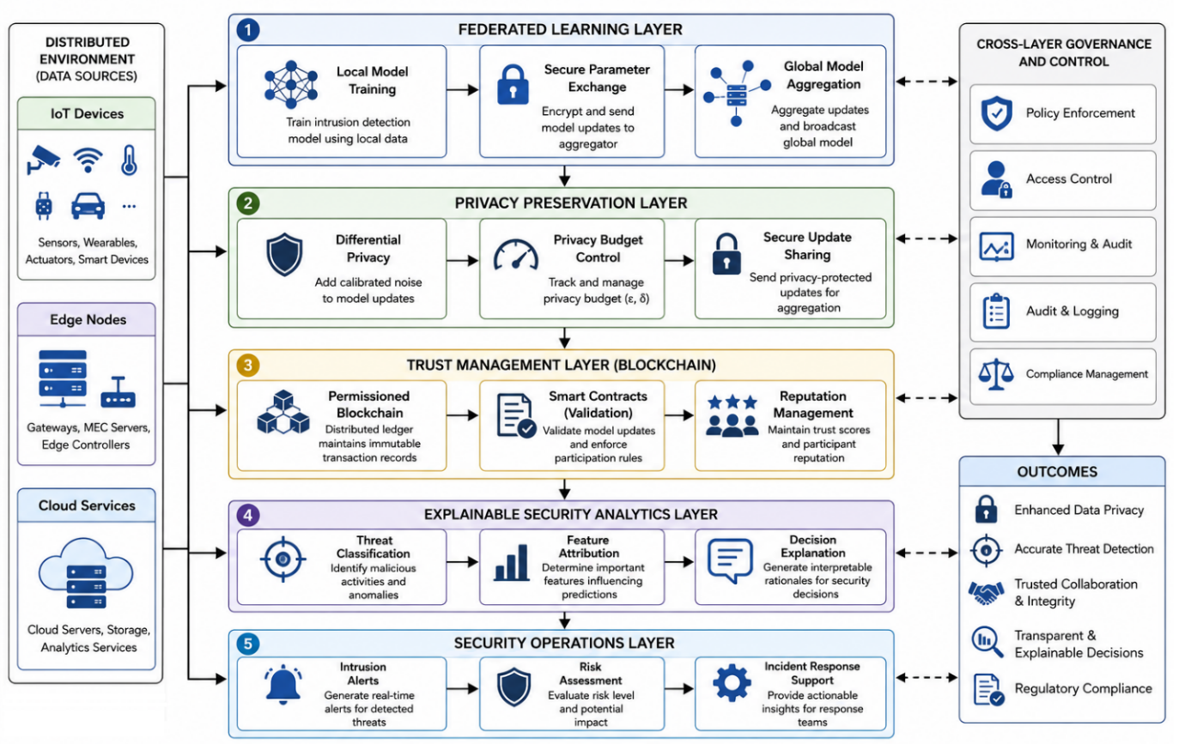
Figure 1. Layered Architecture for Privacy-Preserving Cyber Threat Detection
3.1 Distributed Infrastructure Layer: This layer includes IoT devices, edge servers and cloud resources responsible for collecting and processing security related information. The data remain locally stored within participating nodes.
3.2 Federated Learning Layer: Each participating node independently trains a local intrusion detection model using available security data. Instead of transmitting datasets, only model parameters are exchanged with the federated aggregation server.
3.3 Privacy Preservation Layer: Differential privacy mechanisms are applied before model updates are transmitted. Noise injection reduces the possibility of reconstructing sensitive information from exchanged parameters.
3.4 Trust Management Layer: A permissioned blockchain network stores immutable records of model updates and participant activities. Additionally, the smart contracts verify submitted models and continuously maintain trust scores for participating entities.
3.5 Explainable Security Analytics Layer: The SHAP based explanation techniques identify the most influential features contributing to attack classifications, improve transparency and enable security analysts to interpret model decisions with utmost confidence.
4. Methodology
The framework implementation follows a six-stage operational workflow.
Step 1: Data Collection and Preprocessing: Security logs, network traffic records and system events are collected from IoT devices, edge nodes and cloud services. Data normalization and feature extraction are performed locally at each node.
Step 2: Local Model Training: Each participant trains a local deep learning intrusion detection model using its private dataset $D_{i}$.
$W_{i}^{(t)}= Train(D_{i} ,W^{(t-1)})$ (1)
where
- $D_{i}$denotes the local dataset of participant $i$,
- $W^{\left(t − 1\right)}$represents the global model parameters received from the previous communication round,
- $W_{i}^{\left(t\right)}$denotes the updated local model parameters generated by participant $i$during training round $t$,
- $\text{Train}(⋅)$refers to the local training function implemented using a deep learning optimization algorithm such as Stochastic Gradient Descent (SGD) or Adam.
Step 3: Differential Privacy Protection: Before transmitting the local model updates to the central server, Gaussian noise is added to protect sensitive information and enhance privacy.
${\tilde{W}}_{i}^{\left(t\right)}= W_{i}^{(t)} + N(0 ,σ^{2})$ (2)
where
- ${\tilde{W}}_{i}^{\left(t\right)}$is the privacy-protected model update of participant $i$,
- $W_{i}^{\left(t\right)}$is the locally trained model update,
- $N(0,σ^{2})$denotes Gaussian noise with mean $0$and variance $σ^{2}$,
- $σ$controls the amount of noise added for privacy preservation.
The addition of Gaussian noise helps protect sensitive training information while allowing effective collaborative learning across participants.
Step 4: Federated Aggregation: The aggregation server combines the privacy protected local model parameters received from all participating nodes using the Federated Averaging (FedAvg) algorithm.
$$W_{global}^{(t)}=\sum_{i=1}^{n}{\frac{∣D_{i}∣}{\sum_{j=1}^{n}{∣}D_{j}∣} {\tilde{W}}_{i}^{\left(t\right)}} (3)$$
where
- $W_{\text{global}}^{\left(t\right)}$denotes the aggregated global model at communication round $t$,
- $n$represents the total number of participating nodes,
- $∣D_{i}∣$is the size of the local dataset at node $i$,
- ${\tilde{W}}_{i}^{\left(t\right)}$represents the privacy-protected local model parameters,
- $\frac{∣D_{i}∣}{\sum_{j=1}^{n}{∣}D_{j}∣}$is the weighting factor based on the relative dataset size of node $i$.
The aggregated global model is then distributed to all participating nodes for the next subsequent training round. This approach enables collaborative learning as well as preserves data privacy.
Step 5: Blockchain Validation: The model updates are securely hashed and recorded on a permissioned blockchain. Smart contracts validate participant identities, verify model submissions and continuously update trust scores.
Algorithm 1: Trust Validation
- Receive model update
- Generate cryptographic hash
- Verify participant identity
- Execute smart contract validation
- Update trust score
- Store transaction in blockchain ledger
Step 6: Explainable Threat Classification: The global model performs attack classification, while SHAP values identify influential features contributing to security decisions.
Algorithm 2: Explainable Threat Detection
- Receive network event
- Extract security features
- Execute intrusion detection model
- Generate attack prediction
- Compute SHAP feature importance
- Produce interpretable alert
5. Conclusion
This paper presented the implementation of a privacy-preserving cybersecurity framework for distributed IoT, edge and cloud environments. The proposed architecture integrates federated learning, differential privacy, blockchain-based trust management and explainable artificial intelligence to enable collaborative threat detection along with data confidentiality. The implementation illustrates how decentralized intelligence, privacy preserving techniques and trust mechanisms can be effectively integrated within a unified cybersecurity framework. The proposed solution offers a practical foundation for building secure, transparent and scalable cyber defense systems for emerging digital infrastructures. Future work will focus on large scale deployment, performance optimization and the integration of adaptive threat intelligence mechanisms.
References
- Z. Zhang, M. Li, and A. Alazab, “An intelligent CNN–LSTM based intrusion detection framework for autonomous IoT networks,” IEEE Internet of Things Journal, 2022.
- A. Alazab, N. Islam, and R. J. Alazab, “Deep learning fusion model for IoT threat detection using CNN–GRU,” Future Generation Computer Systems, 2023.
- P. Kairouz et al., “Advances and open problems in federated learning,” Foundations and Trends in Machine Learning, 2021.
- A. Kumar and R. Singh, “Blockchain-driven AI security architecture for intelligent cyber-physical systems,” IEEE Access, 2024.
- R. Bansal and M. Patel, “Blockchain-based trust management framework for autonomous digital systems,” Sensors, 2023.
- T. D. Nguyen, A. Berrada, and D. S. Kim, “Differential privacy-enabled machine learning for cybersecurity applications,” IEEE Transactions on Information Forensics and Security, 2022.
- I. H. Sarker, M. A. Hossain, and S. Khatun, “Privacy-preserving healthcare IoT framework using federated learning and blockchain,” IEEE Journal of Biomedical and Health Informatics, 2023.
- X. Wang, H. Zhao, and K. Yu, “Hybrid privacy-preserving cybersecurity framework for Industry 5.0 systems,” IEEE Transactions on Industrial Informatics, 2024.
- M. Rahman, T. Hasan, and Y. Liu, “Reinforcement learning-based adaptive intrusion prevention in autonomous systems,” Computers & Security, 2023.

